
FinGuard-AI
A Rules-First, Explainable Framework for Narrative-Based Financial Fraud and Consumer-Harm Triage in U.S. Financial Services
Design-science artifact and synthetic demonstration study

Research Snapshot
30  Synthetic cases | 12  Output categories | 4  Auditable scores | 30/30  Complete outputs
A S M FAHIM
UNIVERSITY OF NEW HAVEN, MS FINANCE & FINANCIAL ANALYTICS
ORCID: 0009-0006-3777-5688
Correspondence: asmfahim987@gmail.com
RESEARCH PROTOTYPE | NOT PRODUCTION-READY
This paper reports on a transparent software artifact — now implemented as a tested, publicly deployed platform — and a synthetic demonstration study. It does not claim real-world predictive validation, legal determinations, or production-grade certification.

Abstract
Financial fraud is often visible first in a transaction record, but the complaint narrative usually explains what the ledger cannot: who contacted the consumer, what story was used, how quickly money moved, and what happened when the consumer asked for help. This paper introduces FinGuard-AI, a rules-first risk-triage system that converts those narrative details and a small set of structured case facts into transparent fraud, harm, dispute, and recovery indicators. The system uses explicit weighted phrase rules, not opaque embeddings, to classify narratives into ten substantive fraud, anti-money-laundering, consumer-stress, and disclosure-integrity categories, an “other” category, and an explicit “insufficient evidence” state for narratives that do not support a confident classification. It then produces four bounded 0–100 measures: Fraud Risk, Consumer Harm, Dispute Friction, and Recovery Urgency. Every output can be traced back to matched phrases and visible point adjustments, a nearby-window negation check keeps a denied phrase from scoring as evidence, and a structured-answer conflict check flags contradictions between a consumer's selections and their narrative for manual review. The engine described in an earlier draft of this work as a single local script has since been rebuilt as a tested, publicly deployed platform — a FastAPI backend and a Next.js frontend, covered by a 100-test automated suite and available at a public URL and source repository — so its behavior is open to direct inspection rather than description alone. Following a design-science methodology, the rules engine was exercised on 30 realistic but synthetic cases spanning all requested categories. All cases produced complete classifications, scores, explanations, and recommendations. Mean scores were 74.2, 53.5, 23.6, and 54.7, respectively, and 17 cases met the high-risk queue criterion. Because the cases were constructed for coverage, these results demonstrate functional behavior rather than predictive validity, and no amount of deployment polish changes that. The study contributes an auditable complaint-triage architecture, a multidimensional view of consumer harm, a governance mapping to the NIST AI Risk Management Framework, and a preregistration-ready plan for future evaluation using independently annotated public complaint narratives.
Keywords: financial fraud; consumer complaints; authorized push payment scams; anti-money laundering; explainable artificial intelligence; rules-based systems; consumer harm; dispute resolution; design science; FinTech governance
Scope of evidence: The synthetic demonstration verifies software behavior, category coverage, score bounds, and audit-trail generation. It cannot establish accuracy, calibration, fairness, or effectiveness for real consumers.

Highlights
- A transparent, rules-first engine analyzes complaint narratives without opaque embeddings or black-box predictions.
- The framework separates fraud indicators from consumer harm, dispute friction, and recovery time sensitivity.
- Every score is auditable through visible matched phrases and factor-level point additions or deductions.
- A 30-case synthetic demonstration confirms functional coverage across twelve output categories, including a designed abstention state for insufficient evidence.
- A future validation protocol is specified for public complaint narratives, independent annotation, baselines, robustness, and human-review studies.
- The engine, redaction pipeline, and API are now deployed as a tested, reproducible platform: 100 automated tests, a public source repository, and a live demonstration site, so the described behavior can be checked directly rather than taken on the paper's word.

Abbreviations
Abbreviation | Meaning
AML | Anti-money laundering
APP | Authorized push payment
BEC | Business email compromise
CFPB | Consumer Financial Protection Bureau
DSR | Design-science research
IC3 | Internet Crime Complaint Center
NIST AI RMF | National Institute of Standards and Technology AI Risk Management Framework
PII | Personally identifiable information
SAR | Suspicious Activity Report
XAI | Explainable artificial intelligence

1. Introduction
Financial fraud is not a single operational problem. It may begin with a spoofed bank call, a changed invoice, a fake investment platform, or a relationship built over months. By the time a consumer reports the event, the transaction record shows only part of the story. The narrative may reveal the deception method, the pressure applied, the payment rail used, the consumer’s vulnerability, and the barriers encountered during the dispute. That broader context matters to fraud teams, AML investigators, complaint managers, and consumer-protection specialists. The scale of reported harm reinforces the need for better triage. The Federal Trade Commission reported more than $12.5 billion in consumer-described fraud losses for 2024, while the FBI Internet Crime Complaint Center reported 1,008,597 complaints and $20.877 billion in losses for 2025 (FTC, 2025a; FBI, 2026). The two systems differ in scope and should not be combined, but both show why institutions need methods that can move from a consumer’s account of events to a timely, reviewable response.
Complaint narratives add the human and operational details that transaction data usually omit. A consumer may describe a caller who claimed to represent a bank, a vendor whose payment instructions suddenly changed, a one-time passcode that was disclosed under pressure, an investment platform that demanded another fee, or a dispute that stalled after repeated submissions. These details can change how a case should be routed, what evidence should be preserved, and whether recovery steps are time-sensitive. The CFPB’s public complaint database makes such narratives available for research under defined consent and publication conditions, while appropriately cautioning that complaints are consumer allegations rather than verified findings (CFPB, 2025a, 2025b).
Contemporary fraud research increasingly uses machine learning, deep learning, graph analytics, and natural-language processing. These methods can improve pattern discovery, but real-world deployment remains constrained by class imbalance, concept drift, limited labeled data, privacy restrictions, and the tension between predictive performance and auditability (Hilal et al., 2022; Pourhabibi et al., 2020; Yang et al., 2026). In high-stakes contexts, explanations must permit meaningful review rather than merely provide a persuasive visualization. Rudin (2019) argues that inherently interpretable models should be preferred where feasible, while Doshi-Velez and Kim (2017) and Sokol and Flach (2020) emphasize that explanation quality itself requires systematic evaluation.
Since the first version of this artifact was a single local script, it has been rebuilt as a tested, publicly deployed platform with a documented API, a guided consumer-facing intake flow, and an automated test suite — but the current version remains a research prototype, not a production control. Its purpose is to make assumptions, indicators, thresholds, and limitations visible enough for analysts, researchers, and governance reviewers to inspect and challenge.
This paper makes six contributions:
- An auditable taxonomy for complaint-level fraud, scam, AML/mule-account, consumer-stress, and disclosure-integrity triage.
- Four separate indicators for fraud evidence, consumer harm, dispute friction, and recovery time sensitivity.
- A rules-first Python implementation — now served as a documented API behind a tested, publicly deployed web application — that exposes matched phrases, category rule scores, factor-level score adjustments, negation suppression, and structured-answer conflict detection.
- A synthetic demonstration establishing functional completeness across the intended workflow without overstating predictive validity.
- A governance and evaluation protocol for extending the artifact to independently annotated public or institutional complaint data.
- A reproducible engineering baseline — 100 automated tests, a public source repository, and a live demonstration deployment — so the artifact's behavior is independently verifiable rather than described only in prose.
The remainder of the paper reviews the relevant fraud, complaint-analytics, and explainability literature; describes the design-science method; presents the artifact and synthetic demonstration; maps the system to governance, privacy, security, and accessibility requirements; and defines the empirical work necessary before any operational claims could be justified.

2. Background and Related Work

2.1 Scam typologies, payment speed, and financial-system risk
Scam-related losses arise through heterogeneous mechanisms. Bank impersonation schemes may use spoofed caller identification, urgent security narratives, and requests to disclose authentication codes or transfer funds to a purported “safe account.” Business email compromise can redirect invoice or closing payments by substituting fraudulent beneficiary instructions. Romance and investment schemes may involve extended grooming, fabricated returns, and escalating payments. Marketplace scams exploit trust between counterparties, while money-mule schemes recruit people to receive and forward proceeds. These patterns can overlap: a romance victim may also become an unwitting mule, or an investment scam may use bank impersonation during recovery fraud.
FinCEN advisories describe imposter scams, money-mule schemes, business email compromise, elder financial exploitation, and virtual-currency investment fraud as typologies that financial institutions should evaluate in context (FinCEN, 2019, 2020, 2022, 2023). The advisories treat red flags as indicators rather than conclusive proof. This distinction is central to FinGuard-AI: the system identifies narrative consistency with a typology but does not determine criminal liability, suspicious-activity reporting obligations, reimbursement rights, or the status of a receiving account.
Payment speed changes the operational value of early triage. Wires, instant payments, peer-to-peer transfers, gift cards, cash, and cryptocurrency differ in reversibility, dispute mechanisms, and the information needed for tracing. A narrative-triage system can therefore contribute by separating the probability-like question “does this resemble fraud?” from the operational question “how quickly should recovery or preservation actions be considered?” FinGuard-AI implements this separation through distinct Fraud Risk and Recovery Urgency scores.

2.2 Consumer complaints as risk-intelligence data
Complaint data occupy an intermediate position between customer-service records, regulatory intelligence, and research data. They capture consumer-reported experiences and may reveal recurrent operational failures, communication barriers, and dispute patterns. The CFPB’s public database supports analysis of complaint products, issues, company responses, and narratives, but the Bureau cautions that the data are not a representative statistical sample and that narratives reflect consumer accounts rather than adjudicated facts (CFPB, 2025a, 2025b). Accordingly, a responsible system should describe outputs as indicators derived from reported information.
Recent work has applied NLP and machine learning to complaint classification and outcomes. Jain et al. (2026) compared TF-IDF-based models with a multilingual transformer for bilingual financial complaint classification, while Wang et al. (2026) combined narrative features, topic representations, and structured attributes to predict monetary-relief outcomes in CFPB complaints. These studies demonstrate the analytic value of complaint narratives but also reinforce the need to separate predictive labels from legal or normative judgments. FinGuard-AI differs by focusing on a transparent multidimensional triage output rather than a single product, issue, or relief label.

2.3 Explainability, interpretability, and auditability
Explainability is not a single technical property. LIME approximates a complex model locally around a prediction (Ribeiro et al., 2016), while SHAP assigns additive feature-attribution values (Lundberg & Lee, 2017). Such methods are useful when a complex model is necessary, but post-hoc explanations can be unstable or misunderstood. In contrast, a rules-first system is interpretable by construction when the decision logic, matched evidence, weights, and thresholds are visible.
Interpretability alone does not guarantee validity. A transparent rule can still be poorly specified, biased, incomplete, or overconfident. A proper evaluation must test at least four properties: predictive agreement with independently labeled cases; robustness to linguistic variation and missing information; human ability to understand and challenge the output; and governance controls that record changes, overrides, and outcomes. Sokol and Flach’s (2020) explainability fact-sheet approach and the NIST AI Risk Management Framework provide useful structures for documenting these properties.

2.4 Research gap
The literature contains substantial work on transaction fraud, graph-based anomaly detection, accounting fraud, and complaint classification. Less attention has been given to integrated, complaint-level tools that simultaneously identify scam typologies, measure consumer harm, quantify dispute friction, prioritize recovery urgency, and expose an auditable policy recommendation. FinGuard-AI is designed as a testable response to that gap. The claimed contribution is the artifact and its evaluation framework, not a claim that heuristic rules outperform mature institutional fraud systems.

3. Research Method

3.1 Design-science approach
Design-science research is appropriate when the research objective includes creating and evaluating an artifact that addresses an identified practical problem. Hevner et al. (2004) describe design science as the construction and evaluation of purposeful artifacts, while Peffers et al. (2007) operationalize the process through problem identification, objectives, design and development, demonstration, evaluation, and communication. FinGuard-AI follows this sequence.
DSR stage | Application in this study
Problem identification | Narrative complaints contain fraud, harm, dispute, and recovery information that is difficult to triage consistently and transparently.
Objectives | Provide auditable typology classification, four separate scores, evidence explanations, practical recommendations, and portfolio oversight.
Design and development | Implement weighted phrase rules, structured factor adjustments, bounded scores, and recommendations in Python; serve them through a FastAPI backend and a Next.js frontend (the original Streamlit dashboard is preserved in the repository as a reference version).
Demonstration | Run the complete workflow on 30 realistic but synthetic complaint narratives covering all output categories.
Evaluation | Assess functional completeness, score bounds, category coverage, explanation generation, and known failure risks; define a future empirical protocol.
Communication | Document the architecture, methodology, limitations, reproducibility requirements, and public-service deployment controls.

3.2 Design objectives
- Transparency: each output must be reconstructable from visible rules and case attributes.
- Separation of dimensions: fraud evidence, consumer harm, dispute friction, and recovery urgency must not be collapsed into one score.
- Actionability: the system should translate analysis into a short, reviewable recommendation.
- Abstention readiness: weak or conflicting evidence should be capable of triggering “other,” “insufficient evidence,” or human review in future versions.
- Governance: rules, thresholds, explanations, and overrides should be versioned and auditable.
- Non-adversarial use: the system should support human triage and consumer assistance, not automated adverse decisions.

3.3 Research questions
- RQ1: Can an explicit rules-first artifact operationalize a coherent complaint-level taxonomy across fraud, scam, AML/mule, consumer-stress, and disclosure-integrity cases?
- RQ2: Can fraud evidence, consumer harm, dispute friction, and recovery urgency be represented as separate and auditable indicators?
- RQ3: Does the prototype generate complete, inspectable explanations and recommendations for a diverse synthetic case set?
- RQ4: What governance, privacy, security, and accessibility controls are necessary before the artifact could support real consumers or institutional reviewers?
- RQ5: What empirical design is required to test classification performance, score validity, robustness, and explanation utility on real complaint narratives?

4. FinGuard-AI Artifact Design
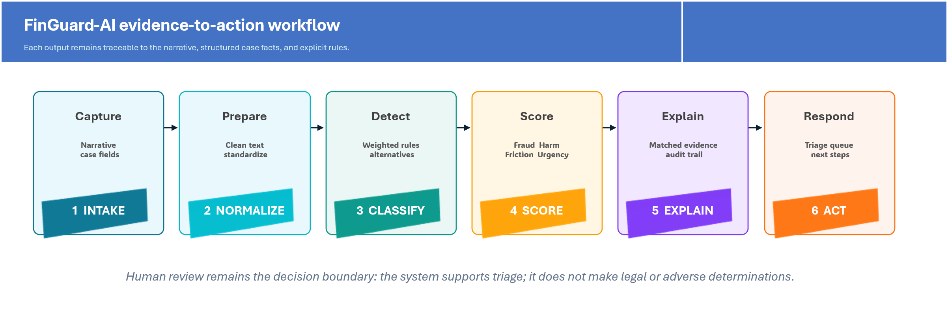
FinGuard-AI rules-first analysis pipeline.

4.1 Inputs and preprocessing
The application accepts either a single narrative or a CSV portfolio with eight fields: case identifier, date, state, narrative, amount lost, payment channel, institution type, and outcome. Before any analysis runs, the narrative passes through a redaction step that strips common sensitive patterns — email addresses, phone numbers, Social Security and payment-card-like number sequences, and disclosed passwords or verification codes — so unredacted personal information does not reach the scoring logic or any log. The sanitized text is then lowercased, punctuation is normalized, and repeated whitespace is removed. Matching is deterministic: multiword phrases use substring matching, single terms use word boundaries, and a one-edit-distance fallback catches common misspellings of single-word indicators. A phrase match found immediately after a negation cue (“did not,” “never”) is suppressed and reported separately rather than scored, so a denial does not count as evidence. The system still does not use stemming, embeddings, or named-entity recognition, and negation handling is a proximity heuristic rather than a full syntactic parse — a limitation discussed in Section 9.

4.2 Typology classification
The rule inventory contains 103 weighted phrases across ten substantive categories, each entry carrying a rule identifier, an effective date, a rationale, and a version, so a reviewer can trace exactly which rule produced a given point of evidence. For a narrative x and typology t, the rule score is the sum of the weights for matched indicators: S(t,x) = Σ w(i,t) I(i,x), where I equals one when indicator i is matched and not negated, and zero otherwise. The category with the highest score is selected. A second category scoring within 60% of the top score is reported as a possible secondary typology, since scam narratives frequently combine mechanisms — a bank-impersonation call that also solicits a mule-style forwarding, for instance. If no category-specific phrase matches, or the top score is negligible on a very short narrative, the output is an explicit “insufficient evidence” state rather than a forced guess, distinct from “other” (some matched evidence, but none of the ten defined categories). An evidence-strength indicator reflects the top score, the number of matched indicators, and the separation from the second-ranked category. It is explicitly not a calibrated probability.
Output category | Operational definition | Illustrative indicators
APP scam | The consumer reports authorizing a transfer after deception or manipulation. | “sent the money myself,” “instant payment,” “transfer was authorized”
Bank impersonation scam | A scammer claims to represent a bank or fraud/security team. | “claimed to be from the bank,” “safe account,” “one-time passcode”
Invoice redirection / BEC | Fraudulent or compromised communications redirect a business or closing payment. | “payment instructions changed,” “vendor email,” “new bank details”
Marketplace scam | A listing, seller, buyer, rental, or off-platform payment is fraudulent. | “online marketplace,” “item never arrived,” “payment outside the platform”
Romance scam | Relationship-building or emotional grooming induces payments. | “dating app,” “said they loved me,” “travel emergency”
Investment scam | A purported investment, trading platform, or withdrawal process is deceptive. | “guaranteed return,” “profits shown,” “withdrawal fee”
AML / mule-account risk | An account receives and forwards funds or exhibits pass-through behavior. | “forward the money,” “keep a commission,” “multiple incoming transfers”
Medical debt / credit stress | The narrative concerns medical billing, collection, or credit-reporting harm. | “medical debt,” “hospital bill,” “credit score dropped”
Mortgage or insurance stress | The narrative concerns servicing, foreclosure, escrow, or insurance claims. | “mortgage servicer,” “foreclosure,” “force-placed insurance”
Financial reporting/ disclosure integrity | The narrative alleges material misstatement, omission, valuation, or control concerns. | “misstated revenue,” “material omission,” “internal controls”
Other | No category-specific phrase reaches a positive score. | Fallback; manual review is appropriate
Insufficient evidence | No meaningful narrative evidence is found and the input is too short to support a confident category. | N/A (abstention state, not a classification)
FinGuard-AI typology taxonomy. Indicators are illustrative, not exhaustive or determinative.

4.3 Four score dimensions
Each score is clamped to an integer from 0 to 100. The point systems are heuristics intended for transparent demonstration. They have not been calibrated to observed probabilities or validated against expert ratings. The separation of score dimensions is a core design decision: a low-dollar case can have high fraud evidence but moderate consumer harm, while a non-fraud servicing case can have low fraud risk but high dispute friction or housing-related harm.
Dimension | Primary inputs | Interpretation
Fraud Risk Score | Typology base value; credential compromise; spoofing; urgency; false safe-account instruction; payment channel; amount; confirmed-fraud outcome. | Strength of narrative and transaction indicators associated with fraud.
Consumer Harm Score | Loss magnitude; age/fixed-income vulnerability; disability; language barriers; medical or housing stress; essential funds; repeat victimization; recovery outcome. | Severity and persistence of reported financial and personal harm.
Dispute Friction Score | Denial; case closure; no response; repeated contacts; transfers; duplicate evidence requests; appeal; provisional-credit reversal; delay; resolution. | Reported procedural burden in obtaining review or remediation.
Recovery Urgency Score | Payment-channel reversibility; typology; fraud score; recency; pending status; loss amount; unresolved outcome; reported recovery. | Time sensitivity of freeze, recall, tracing, stop-payment, or evidence-preservation action.
Score construction and intended interpretation.

4.4 Explanation and recommendation generation
For each case, the interface displays the selected typology, matched category indicators (including any negated indicators found but not scored), alternative categories with nonzero evidence, and the complete factor list for all four scores. A separate conflict check compares structured answers against the narrative — for example, a consumer marking a payment as authorized while writing that they “never approved the transfer” — and flags the contradiction for manual review rather than silently picking one answer. Recommendations are generated from visible branches and organized into a short action plan (immediate steps, account security, evidence to preserve, what to ask the institution, and follow-up), an evidence checklist tailored to the reported payment channel and typology, and editable dispute-letter drafts built only from the sanitized case facts. For example, APP and bank-impersonation cases surface escalation and reimbursement-review language; BEC cases surface beneficiary-bank outreach and wire-recall review; mule-account cases surface receiving-side risk review and transaction-record preservation; and cryptocurrency channels surface preservation of wallet addresses and transaction hashes. The application uses cautious, non-adjudicative language throughout (“may warrant,” “is recommended”) and does not represent these actions as legal entitlements or state that fraud occurred.

4.5 Portfolio dashboard
The portfolio view summarizes total cases, cases meeting the high-risk queue criterion, mean scores across all four dimensions, total reported loss, typology and payment-channel distribution, severity distribution, and high-risk case details, and it is clearly labeled as synthetic demonstration data rather than real consumer records. Users may download an analyzed CSV containing case inputs, classifications, scores, indicators, and recommendations, or upload their own CSV against the same schema for a private, in-memory analysis that is not stored. A companion public rule-explorer page lists every phrase rule with its identifier, weight, and rationale, so the classification logic described in Section 4.2 is independently browsable rather than described only in this paper. This feature demonstrates how a narrative-level engine can support operational oversight in addition to single-case assistance.

4.6 Deployment architecture and reproducibility
The design described above is implemented as two coordinated services rather than a single script. A FastAPI backend exposes the redaction, classification, scoring, recommendation, and PDF-report logic as a documented HTTP API, with request-size limits, per-IP rate limiting, and restrictive security response headers applied by default. A Next.js frontend implements the guided consumer-facing workflow — a safety notice, a short urgency screen, structured intake, a redaction preview the user can check before analysis proceeds, the explainable results view, and the action-plan, evidence-checklist, timeline, and dispute-letter tools described in Section 4.4 — and the synthetic-data portfolio dashboard. Every typology, every negation and conflict case, every redaction pattern, and every score-boundary condition described in this paper is covered by an automated test (100 tests at the time of writing), run on every change through a continuous-integration workflow. The source code, tests, Docker configuration, and documentation are maintained in a public repository, and a live demonstration deployment is available for direct inspection rather than only textual description (see Declarations). None of this establishes predictive validity; it establishes that the described behavior is real, reproducible, and open to scrutiny, which Section 7 treats as a precondition for, not a substitute for, empirical evaluation.

5. Synthetic Demonstration Study

5.1 Dataset and procedure
The demonstration dataset contains 30 realistic but fictional narratives dated in July 2026. The cases cover bank impersonation, APP scams, BEC, marketplace fraud, romance and investment scams, money-mule risk, medical-debt and credit stress, mortgage or insurance stress, financial-reporting concerns, and an “other” case. The narratives include payment channels, loss amounts, institution types, dispute outcomes, and harm indicators. No narrative describes an actual person or event.
The dataset was processed through the same deterministic risk_engine package that now runs behind the deployed API described in Section 4.6, so the results below reflect the production code path rather than a separate research script. Functional checks confirmed the required schema, unique identifiers, valid dates, bounded scores, populated recommendations, and category coverage; the same checks are re-run automatically as part of the 100-test suite on every code change. The high-risk queue criterion was defined as Fraud Risk ≥70, Consumer Harm ≥75, or Recovery Urgency ≥75.

5.2 Descriptive results
Measure | Demonstration result
Cases processed | 30
Total synthetic reported amount lost | $627,910
Median synthetic amount lost | $8,900
Cases with nonzero loss | 28
High-risk queue cases | 17 (56.7%)
Mean Fraud Risk Score | 74.2
Mean Consumer Harm Score | 53.5
Mean Dispute Friction Score | 23.6
Mean Recovery Urgency Score | 54.7
Descriptive results for the synthetic demonstration set.
Important interpretation: These values show how the rules behave on constructed examples. They are not prevalence estimates, accuracy estimates, calibrated risks, or evidence of real-world effectiveness.
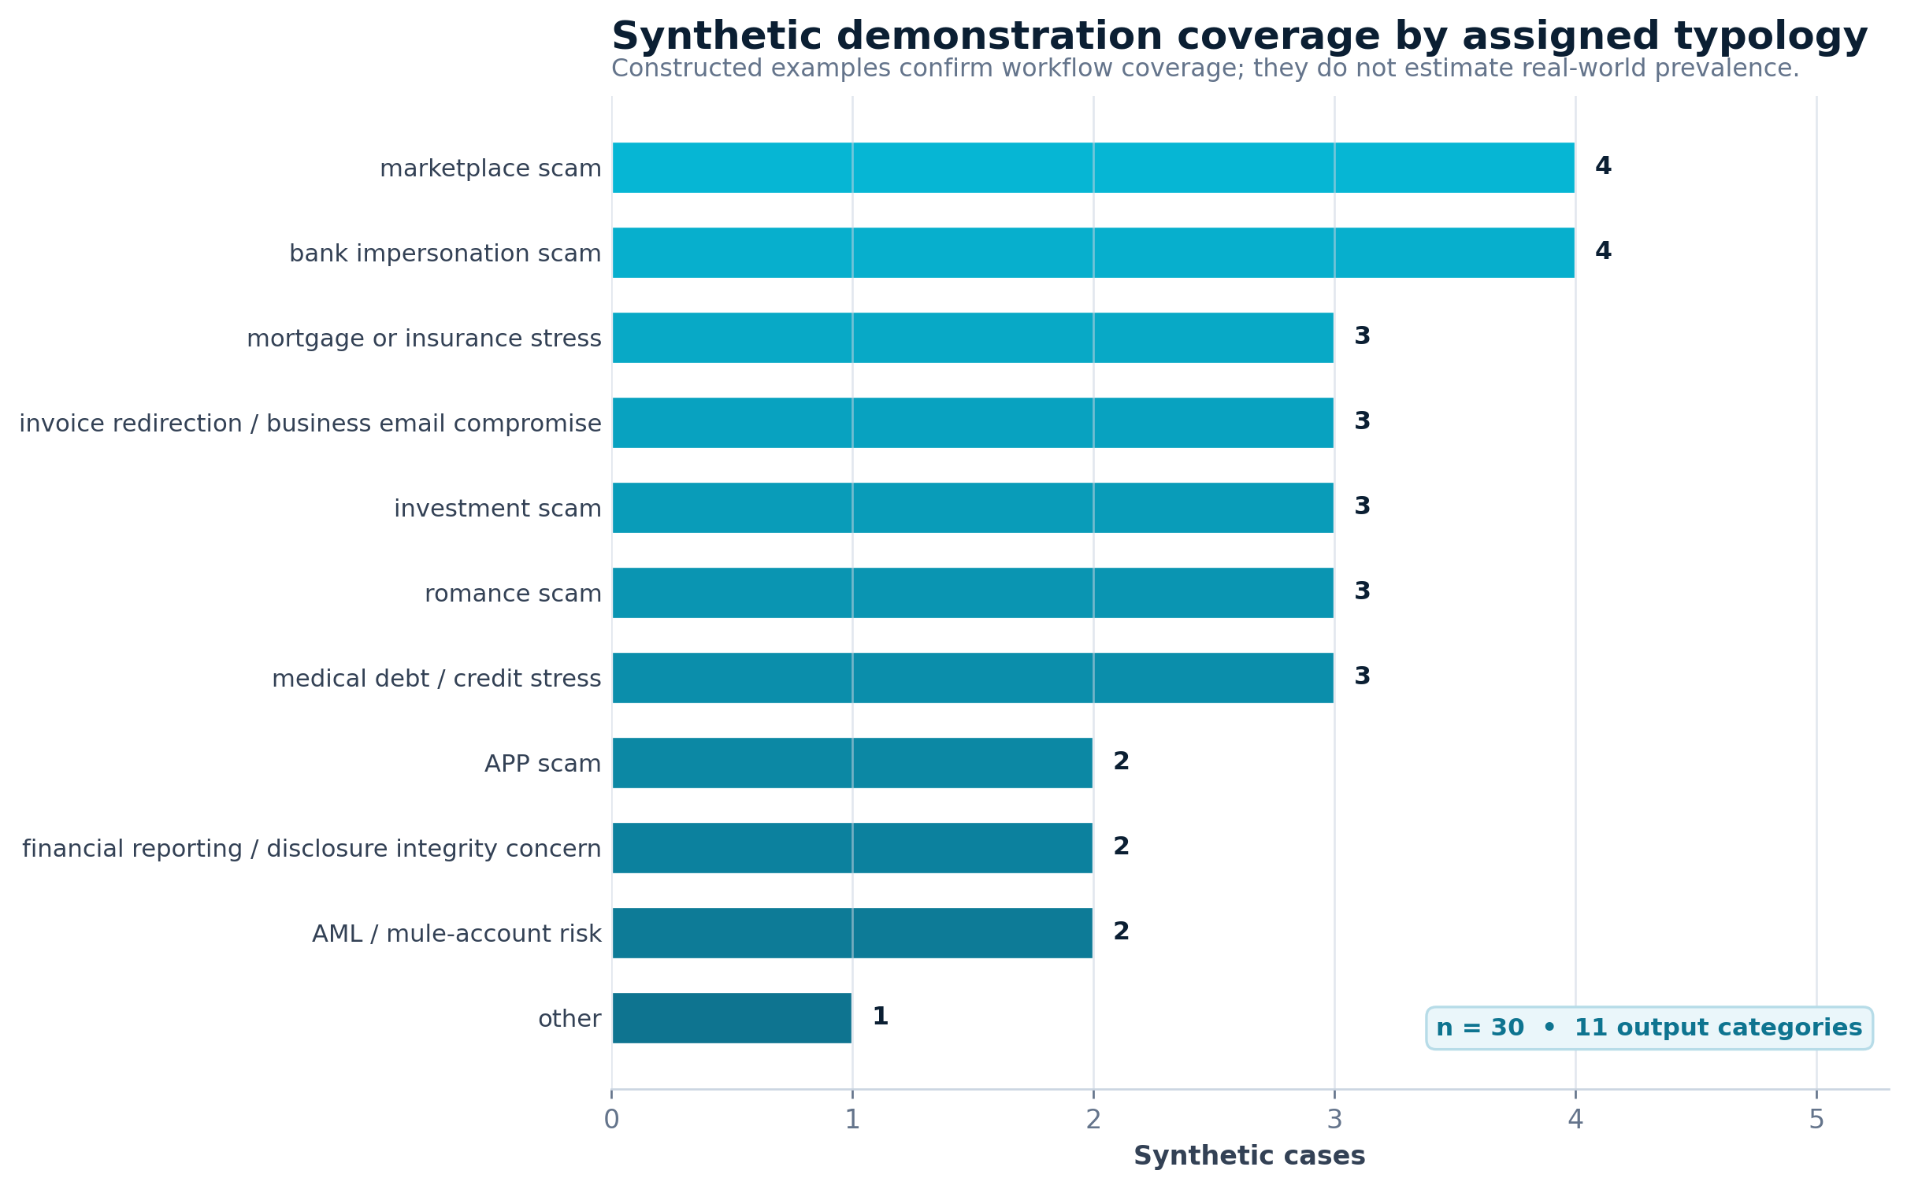
Distribution of synthetic cases by assigned typology.
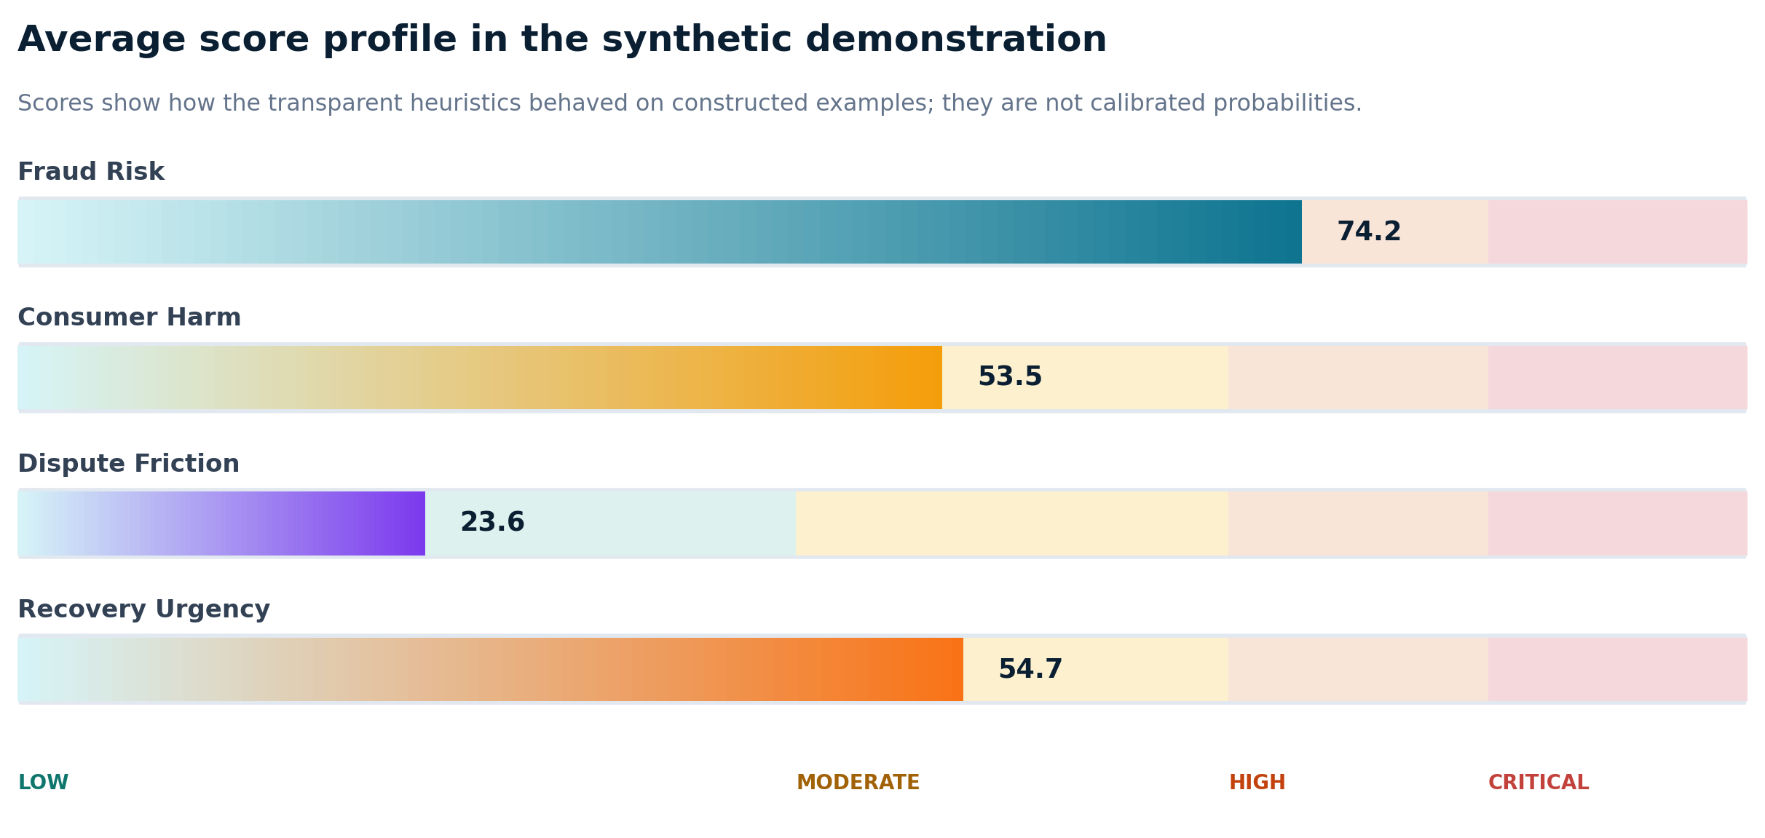
Mean scores in the synthetic demonstration set.
The system assigned 15 cases to the Critical band, 2 to High, 12 to Moderate, and 1 to Low. This distribution is expected to be risk-enriched because the dataset was constructed to demonstrate fraud and harm scenarios rather than reproduce a population distribution.
Case | Assigned typology | F/H/D/U scores | Recommendation excerpt
FG-0001 | bank impersonation scam | 100/44/10/94 | Escalate for bank-impersonation and APP scam review. Initiate freeze, recall, or stop-payment steps where operationally available. Check receiving-side account, device, and beneficiary risk indicators.
FG-0002 | invoice redirection / business email compromise | 99/53/10/93 | Initiate beneficiary-bank outreach and wire recall review. Initiate freeze, recall, or stop-payment steps where operationally available. Check receiving-side account, device, and beneficiary risk indicators.
FG-0007 | medical debt / credit stress | 28/53/22/18 | Validate billing, collection authority, and credit-reporting accuracy.
FG-0022 | APP scam | 92/61/58/78 | Escalate for APP scam review and assess reimbursement eligibility. Initiate freeze, recall, or stop-payment steps where operationally available. Check receiving-side account, device, and beneficiary risk indicators.
FG-0030 | other | 46/60/62/36 | Request additional evidence and route for manual risk review. Assess credential compromise and secure affected access channels.
Illustrative synthetic case outputs. F/H/D/U = Fraud Risk, Consumer Harm, Dispute Friction, and Recovery Urgency.

5.3 Functional findings
- All 30 records were processed without missing score or recommendation outputs.
- All four score dimensions remained within the required 0–100 bounds.
- The output set covered all ten substantive typologies and the “other” fallback.
- The application produced both case-level explanations and a portfolio-level high-risk queue.
- Outcome text affected continuing harm, dispute friction, and recovery urgency as intended.
- The demonstration exposed a design limitation that has since been partially addressed: phrase rules required an explicit contextual safeguard for negation, which the deployed matcher now applies as a nearby-window cue check (Section 4.1). Broader safeguards for ambiguity and synonymous wording remain future work.

6. Governance and Public-Service Deployment

6.1 NIST AI RMF mapping
The NIST AI RMF describes four core functions Govern, Map, Measure, and Manage and identifies validity, safety, security, accountability, transparency, explainability, privacy, and fairness as characteristics of trustworthy AI systems (NIST, 2023). FinGuard-AI can be mapped to this framework even though the present artifact is rules-based rather than a trained model.
AI RMF function | FinGuard-AI control objectives
Govern | Assign rule owners; approve changes; version rule dictionaries and thresholds; define prohibited uses; maintain override and incident procedures.
Map | Document users, decision context, affected consumers, data flows, foreseeable misuse, legal boundaries, and consequences of false positives and false negatives.
Measure | Evaluate per-class precision/recall, abstention, score agreement, robustness, subgroup performance, explanation usefulness, accessibility, and security.
Manage | Require human review for high-impact outputs; monitor drift and complaints; suspend unsafe rules; preserve audit logs; provide correction and deletion processes.
Governance mapping to the NIST AI Risk Management Framework.

6.2 Consumer-help workflow
A public-facing version should not begin with an unstructured scoring screen, and the deployed prototype does not: it opens with a safety notice, then a short screen for urgent loss, pending transactions, credential compromise, remote access, and immediate account-security needs, before any narrative is entered. It warns users not to submit passwords, PINs, Social Security numbers, full account or card numbers, or one-time codes, and it applies the automatic redaction described in Section 4.1 as a second, best-effort safeguard rather than the only one. Structured questions capture the incident date, payment channel, authorization status, contact method, impersonated entity, evidence available, dispute status, and hardship indicators. Results present an action plan, an evidence checklist, official reporting resources (with an explicit statement that the platform does not file reports on the user's behalf), a case timeline, and dispute-letter drafts, alongside a clear, repeated statement that the assessment is informational and not a legal or financial determination.

6.3 Privacy, security, and accessibility
A public implementation should support data minimization, automatic redaction, explicit consent, short retention periods, encryption in transit and at rest, role-based access, multi-factor authentication for reviewers, secure file scanning, rate limiting, audit logging, and deletion requests. The deployed prototype now implements several of these directly by default: automatic redaction before analysis, no persistent storage of raw narrative text or structured case data, restrictive security response headers, per-IP rate limiting, and request-size limits enforced at the schema level. It does not implement authenticated case storage, encryption at rest (there is, by design, no persistent case database to encrypt), multi-factor reviewer authentication, or a completed independent third-party security audit, and none of these gaps should be read as resolved by the controls that do exist.
Application-security requirements should be verified against a recognized standard such as the OWASP Application Security Verification Standard, and customer security should be treated as a core product requirement consistent with CISA Secure by Design principles (CISA, 2023; OWASP Foundation, 2025); that verification has not yet been performed for this artifact. The public interface targets WCAG 2.2 Level AA through keyboard navigation, skip-navigation links, visible focus states, semantic structure, sufficient contrast, and reduced-motion support, but this has been implemented as a set of engineering practices, not confirmed through a formal accessibility audit (World Wide Web Consortium [W3C], 2023).
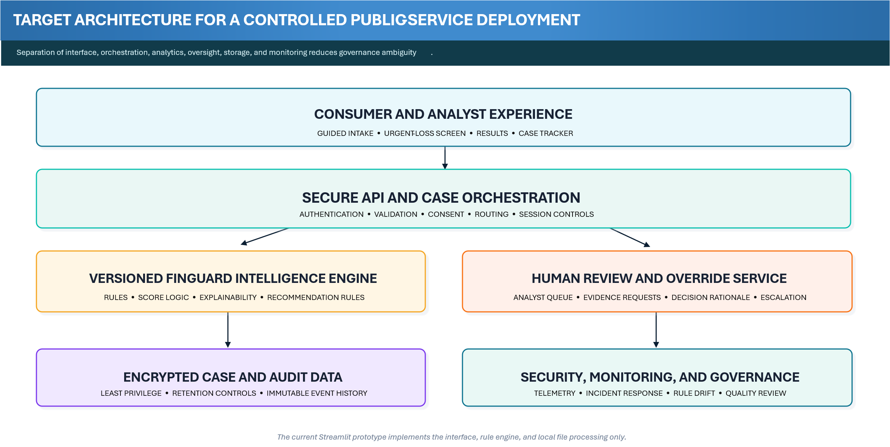
Target architecture for controlled public-service deployment.

6.4 Human review and decision boundaries
FinGuard-AI outputs should support, not replace, professional review. The system should never state that a bank must reimburse a consumer, that a person committed fraud, that an account is definitively a money-mule account, or that a SAR must be filed. Safer language includes “indicators are consistent with,” “the case may warrant,” and “request review of eligibility.” High-risk, conflicting, or low-evidence cases should be routed to human review, and reviewers should record whether they accepted, modified, or rejected the automated recommendation and why.

7. Empirical Validation Protocol

7.1 Data source and sampling
The next study should use a documented sample of public complaint narratives, initially from the CFPB Consumer Complaint Database. The database permits CSV and JSON downloads and includes narratives only under the Bureau’s publication process (CFPB, 2025a, 2025b). Because the data are not a representative survey and allegations are not verified, the study should evaluate agreement with expert annotation of reported narrative characteristics, not “ground-truth fraud.” A first study could target approximately 1,000–1,500 English-language narratives, stratified by relevant products and issues while preserving natural prevalence in a final test set.

7.2 Annotation and adjudication
- Prepare a codebook with definitions, inclusions, exclusions, positive examples, neighboring categories, multi-label rules, and insufficient-evidence criteria.
- Use at least two independent reviewers who do not see the prototype output during initial labeling.
- Train reviewers on a separate calibration set and freeze the codebook before formal annotation.
- Record one primary typology, an optional secondary typology, four ordinal score ratings, missing evidence, and reviewer confidence.
- Calculate Cohen’s kappa, weighted kappa, or Krippendorff’s alpha as appropriate, and preserve original labels after adjudication.

7.3 Evaluation metrics and baselines
Evaluation domain | Recommended measures
Typology classification | Macro and weighted precision, recall, F1; per-class metrics; confusion matrix; abstention coverage and selective accuracy.
Four scores | Spearman correlation with reviewer ratings; mean absolute error; weighted kappa after score banding; threshold sensitivity and specificity.
Robustness | Performance under synonyms, misspellings, negation, shortened narratives, reordered sentences, missing fields, and conflicting statements.
Explainability | Reviewer ability to identify relevant evidence, detect incorrect rules, understand score contributions, and complete review efficiently.
Fairness and access | Performance by available language, state, product, narrative length, payment channel, age-related indicators, and other ethically justified groups.
Table 6. Recommended empirical evaluation measures.
Baselines should include a majority-class predictor, a simple keyword-count method, TF-IDF with logistic regression, and TF-IDF with a linear support-vector classifier. A transformer model may be included as a higher-capacity comparator. The rules should be developed on a development set, thresholds selected on a validation set, and the final test set evaluated once after the artifact is frozen. The most informative result may be a trade-off rather than outright superiority: a rules-first method could provide lower predictive performance than a transformer while offering stronger traceability and easier governance.

7.4 Explainability and reviewer-utility study
A human-grounded study should compare review with and without FinGuard-AI assistance. Reviewers can rate whether the explanation identifies relevant evidence, whether the score rationale is understandable, whether the recommendation follows from the evidence, and whether the system helps them identify missing information. Outcomes should include review time, agreement, error-detection rate, explanation usefulness, and the proportion of recommendations accepted, modified, or rejected. This design follows calls for application-grounded interpretability evaluation rather than assuming that visible features are automatically useful (Doshi-Velez & Kim, 2017; Sokol & Flach, 2020).

8. Discussion

8.1 What the artifact contributes
The central lesson from the prototype is practical: complaint triage becomes easier to govern when it is broken into separate questions. What reported mechanism best fits the narrative? How strong are the fraud indicators? How severe is the consumer harm? How difficult has the dispute process become? How quickly might recovery opportunities close? FinGuard-AI answers those questions separately, then shows the evidence and point adjustments behind each answer. That separation makes disagreements visible. An analyst can accept the typology but challenge the urgency score, or agree that harm is severe while requesting more evidence before treating the receiving account as suspicious.
The artifact also connects consumer protection and AML perspectives. A person may be both a victim and an unwitting mule; a receiving account may present risk indicators even when the sending consumer authorized the payment; and repeated disputes may reveal consumer harm even where fraud cannot be established. The system therefore encourages cross-functional review among fraud operations, AML, complaints, conduct risk, cybersecurity, and consumer-assistance teams.
“ | Design principle: A useful explanation should help a reviewer question the system—not simply make the system sound confident.

8.2 Interpretability versus adaptability
Rules-first systems are easy to audit but can be brittle. Exact phrases may miss synonyms and indirect descriptions, and weights can encode untested judgments. Machine-learning models can generalize across language but introduce data dependency, drift, and explanation challenges. A sensible future architecture is hybrid: explicit rules for high-confidence red flags and safety constraints; an interpretable statistical classifier for broader language coverage; disagreement detection; and mandatory human review when components conflict.

8.3 Policy and operational implications
For financial institutions, the prototype illustrates how narrative intelligence might improve complaint routing, escalation, receiving-side review, recovery coordination, and management reporting. For consumer-assistance organizations, it illustrates how a guided intake can convert a distressing narrative into a prioritized checklist without making legal promises. For regulators and researchers, the artifact offers a reproducible object for testing explainability, complaint taxonomies, consumer-harm measures, and cross-functional governance.
The work should not be framed as a replacement for transaction monitoring, identity verification, sanctions controls, suspicious activity reporting, legal analysis, or case-management platforms. Its value lies in a specific layer: transparent narrative triage and decision support.

9. Limitations
- Synthetic evidence: the 30 cases were constructed to exercise the software and cannot establish predictive validity or prevalence.
- Rule brittleness: exact matching is sensitive to synonyms, misspellings, narrative structure, and implicit meaning.
- Negation and context: the deployed matcher now suppresses a phrase match found near a negation cue such as “did not” or “never,” verified by dedicated tests, so “the caller never claimed to be from my bank” no longer scores as a positive match. This is a proximity heuristic, not a syntactic parse, and it can still miss negation expressed across a longer clause, double negatives, or reported speech (“they said they were not really the bank, but I didn't believe them”).
- Forced single-label output: overlapping scam mechanisms are common, but the current interface selects one primary typology.
- Heuristic weights: category weights and score adjustments reflect design judgment rather than statistical calibration or expert consensus.
- Data limitations: public complaints are self-reported, selectively published, nonrepresentative, and not verified adjudications.
- Language limitation: the current rule dictionary is English-only and has not been tested for dialect, literacy, or language-access effects.
- Security limitation: the deployed prototype now applies redaction, security response headers, and rate limiting by default, but it has not undergone an independent third-party security audit or penetration test, and it still lacks the authenticated storage, encryption-at-rest, and formal monitoring and incident-response controls that a production deployment handling real, sensitive submissions would require.
- No legal determination: the artifact does not determine reimbursement eligibility, regulatory violations, SAR obligations, or criminal conduct.
- No outcome study: there is no evidence yet that using the tool improves recovery, reduces harm, or improves reviewer decisions.
- Engineering completeness is not empirical validity: a passing automated test suite and a stable public deployment demonstrate that the software behaves as specified on the inputs it was designed for; they are not a substitute for the independently annotated evaluation described in Section 7, which has not yet been conducted.

10. Future Development Roadmap
Phase | Primary deliverables
Phase 1: Reproducible research release (complete) | Versioned code, synthetic data, rule inventory, methodology, a 100-test automated suite, and a stable public demonstration deployment with no real-data storage are published and live.
Phase 2: Public-data validation | Retrieve and annotate CFPB narratives; implement abstention, multi-label outputs, negation handling, baselines, and robustness tests.
Phase 3: Expert utility study | Evaluate review time, agreement, explanation usefulness, override patterns, and recommendation quality with qualified reviewers.
Phase 4: Controlled pilot | Deploy a secure API, encrypted database, role-based analyst portal, PII redaction, consent and deletion controls, monitoring, and incident response.
Phase 5: Continuous governance | Monitor drift, false positives, false negatives, consumer feedback, subgroup performance, security events, and rule/version changes.
Recommended research and deployment roadmap.

11. Conclusion
Its contribution is more focused: it organizes narrative evidence into an auditable workflow that keeps fraud indicators, consumer harm, dispute friction, and recovery urgency distinct, and it now does so as a tested, publicly deployed platform rather than only a local script. The 30-case synthetic study confirms that the software functions across the intended categories and produces complete explanations, but it does not establish accuracy on real complaints, and a stable deployment does not change that. The next stage is therefore empirical rather than cosmetic: independently annotated public narratives, frozen rules, transparent baselines, robustness tests, and human-review studies. With those safeguards, FinGuard-AI can mature from a credible, reproducible research prototype into a well-evaluated contribution to financial-fraud intelligence and consumer-protection governance.

Declarations
Funding: No external funding is reported for the current prototype and manuscript draft.
Conflicts of interest: The author is the developer of the FinGuard-AI research prototype. No other conflicts are declared.
Ethics statement: The demonstration dataset is entirely synthetic and contains no real consumer records. Any future study involving nonpublic institutional data or human participants should obtain the required institutional, legal, privacy, and ethics approvals before data collection.
Data availability: The synthetic demonstration CSV, methodology, and data dictionary are available in the public repository referenced under Code availability. Public complaint data should be retrieved from the originating agency using a documented query rather than redistributed unnecessarily.
Code availability: The platform is implemented in Python (FastAPI, Pydantic, pandas, reportlab) and TypeScript (Next.js). The source code, the 100-test automated suite, Docker configuration, and CI workflow are maintained in a public repository at https://github.com/ASMNIR/finguard-ai. A live demonstration deployment is available at https://frontend-five-liard-58.vercel.app (API at https://finguard-ai-api.onrender.com). A DOI-backed archival release should still be created before formal journal submission.
Author contributions: Conceptualization, methodology, software, validation, visualization, writing original draft and writing review and editing: A S M FAHIM.

References
Bao, Y., Ke, B., Li, B., Yu, Y. J., & Zhang, J. (2020). Detecting accounting fraud in publicly traded U.S. firms using a machine learning approach. Journal of Accounting Research, 58(1), 199–235. https://doi.org/10.1111/1475-679X.12292
Consumer Financial Protection Bureau. (2025a). Consumer Complaint Database. https://www.consumerfinance.gov/data-research/consumer-complaints/
Consumer Financial Protection Bureau. (2025b). How we share complaint data. https://www.consumerfinance.gov/complaint/data-use/
Cybersecurity and Infrastructure Security Agency. (2023). Secure by Design. https://www.cisa.gov/securebydesign
Doshi-Velez, F., & Kim, B. (2017). Towards a rigorous science of interpretable machine learning. arXiv:1702.08608. https://arxiv.org/abs/1702.08608
Federal Bureau of Investigation. (2026). 2025 IC3 Annual Report. Internet Crime Complaint Center. https://www.ic3.gov/AnnualReport/Reports/2025_IC3Report.pdf
Federal Bureau of Investigation. (2024). Business email compromise: The $55 billion scam. Internet Crime Complaint Center. https://www.ic3.gov/PSA/2024/PSA240911
Federal Trade Commission. (2025a). New FTC data show a big jump in reported losses to fraud to $12.5 billion in 2024. https://www.ftc.gov/news-events/news/press-releases/2025/03/new-ftc-data-show-big-jump-reported-losses-fraud-125-billion-2024
Federal Trade Commission. (2025b). Consumer Sentinel Network Data Book 2024. https://www.ftc.gov/reports/consumer-sentinel-network-data-book-2024
Financial Crimes Enforcement Network. (2019). Updated advisory on email compromise fraud schemes targeting vulnerable business processes (FIN-2019-A005). https://www.fincen.gov/system/files/advisory/2019-07-16/Updated%20BEC%20Advisory%20FINAL%20508.pdf
Financial Crimes Enforcement Network. (2020). Advisory on imposter scams and money mule schemes related to Coronavirus Disease 2019 (FIN-2020-A003). https://www.fincen.gov/system/files/advisory/2020-07-07/Advisory_%20Imposter_and_Money_Mule_COVID_19_508_FINAL.pdf
Financial Crimes Enforcement Network. (2022). Advisory on elder financial exploitation (FIN-2022-A002). https://www.fincen.gov/system/files/advisory/2022-06-15/FinCEN%20Advisory%20Elder%20Financial%20Exploitation%20FINAL%20508.pdf
Financial Crimes Enforcement Network. (2023). FinCEN alert on prevalent virtual currency investment scam commonly known as “pig butchering” (FIN-2023-Alert005). https://www.fincen.gov/system/files/shared/FinCEN_Alert_Pig_Butchering_FINAL_508c.pdf
Hevner, A. R., March, S. T., Park, J., & Ram, S. (2004). Design science in information systems research. MIS Quarterly, 28(1), 75–105. https://www.jstor.org/stable/25148625
Hilal, W., Gadsden, S. A., & Yawney, J. (2022). Financial fraud: A review of anomaly detection techniques and recent advances. Expert Systems with Applications, 193, 116429. https://doi.org/10.1016/j.eswa.2021.116429
Jain, P., Tripathi, S., Garg, T., Sadashiv, N., Kundur, N. C., Phadke, M., Gaikwad, M., et al. (2026). An intelligent transformer based framework for bilingual financial complaint classification. Scientific Reports, 16, 20594. https://doi.org/10.1038/s41598-026-51771-w
Lundberg, S. M., & Lee, S.-I. (2017). A unified approach to interpreting model predictions. Advances in Neural Information Processing Systems, 30. https://arxiv.org/abs/1705.07874
National Institute of Standards and Technology. (2020). NIST Privacy Framework: A tool for improving privacy through enterprise risk management, Version 1.0. https://www.nist.gov/privacy-framework
National Institute of Standards and Technology. (2023). Artificial Intelligence Risk Management Framework (AI RMF 1.0) (NIST AI 100-1). https://doi.org/10.6028/NIST.AI.100-1
OWASP Foundation. (2025). OWASP Application Security Verification Standard. https://owasp.org/www-project-application-security-verification-standard/
Peffers, K., Tuunanen, T., Rothenberger, M. A., & Chatterjee, S. (2007). A design science research methodology for information systems research. Journal of Management Information Systems, 24(3), 45–77. https://doi.org/10.2753/MIS0742-1222240302
Pourhabibi, T., Ong, K.-L., Kam, B. H., & Boo, Y. L. (2020). Fraud detection: A systematic literature review of graph-based anomaly detection approaches. Decision Support Systems, 133, 113303. https://doi.org/10.1016/j.dss.2020.113303
Ribeiro, M. T., Singh, S., & Guestrin, C. (2016). “Why should I trust you?”: Explaining the predictions of any classifier. Proceedings of the 22nd ACM SIGKDD International Conference on Knowledge Discovery and Data Mining, 1135–1144. https://doi.org/10.1145/2939672.2939778
Rudin, C. (2019). Stop explaining black box machine learning models for high stakes decisions and use interpretable models instead. Nature Machine Intelligence, 1, 206–215. https://doi.org/10.1038/s42256-019-0048-x
Sokol, K., & Flach, P. (2020). Explainability fact sheets: A framework for systematic assessment of explainable approaches. Proceedings of the 2020 Conference on Fairness, Accountability, and Transparency, 56–67. https://doi.org/10.1145/3351095.3372870
Wang, Z., Zhu, S., & Chen, X. (2026). From complaint narratives to monetary relief: A hybrid machine learning framework for CFPB consumer complaints. arXiv:2606.22664. https://arxiv.org/abs/2606.22664
World Wide Web Consortium. (2023). Web Content Accessibility Guidelines (WCAG) 2.2. https://www.w3.org/TR/WCAG22/
Yang, H., Shukur, Z., & Sahran, S. (2026). A review of artificial intelligence for financial fraud detection. Applied Sciences, 16(4), 1931. https://doi.org/10.3390/app16041931

Appendix A. Rule Inventory Summary
Category | Rule count | Example phrases
APP scam | 10 | authorized push payment; authorized the transfer; sent the money myself; peer to peer; …
bank impersonation scam | 11 | pretended to be my bank; claimed to be from the bank; bank fraud department; spoofed bank number; …
invoice redirection / business email compromise | 11 | invoice; vendor email; supplier email; business email compromise; …
marketplace scam | 10 | online marketplace; marketplace seller; marketplace buyer; item never arrived; …
romance scam | 10 | dating app; romantic relationship; online relationship; said they loved me; …
investment scam | 10 | investment platform; guaranteed return; crypto investment; trading coach; …
AML / mule-account risk | 11 | received funds for someone else; forward the money; keep a commission; money mule; …
medical debt / credit stress | 10 | medical debt; hospital bill; medical collection; credit report; …
mortgage or insurance stress | 10 | mortgage servicer; foreclosure; escrow; loan modification; …
financial reporting / disclosure integrity concern | 10 | financial statements; misstated revenue; undisclosed related party; material omission; …
Other | 0 | Fallback when no category-specific phrase is matched
Insufficient evidence | 0 | Abstention state; triggered when no rule matches and the narrative is very short
Summary of the version 1.0 typology rule dictionary.
The complete rule dictionary is implemented in backend/app/risk_engine/rules.py as version-controlled records, each carrying a rule identifier, source, rationale, effective date, an enabled flag, and a version — the configuration structure recommended in the first draft of this paper as future work has since been built directly, and every rule is exercised by the automated test suite.

Appendix B. Scoring Audit Requirements
Audit element | Minimum record
Case provenance | Case ID, source, consent/publication status, ingestion timestamp, and data-retention status.
Input snapshot | Narrative and structured values exactly as analyzed, with PII redaction status.
Rule metadata | Application version, rule-set version, score version, and recommendation version.
Classification evidence | Matched indicators, weights, category scores, alternative categories, and abstention reason.
Score evidence | Base value and every positive or negative adjustment for all four dimensions.
Human review | Reviewer, status, accepted/modified/rejected output, override reason, and final disposition.
Monitoring outcome | Recovery result, dispute outcome, confirmed error, complaint, incident, or feedback tied to the output.
Minimum audit record for controlled deployment.

Appendix C. Reproducibility Checklist
- Source code and dependency file are version controlled.
- Synthetic data are clearly labeled and included.
- Rule dictionary and score weights are frozen for each reported experiment.
- Data retrieval query, date, filters, exclusions, and deduplication are documented.
- Annotation codebook and reviewer instructions are archived.
- Development, validation, and test assignments are reproducible.
- All metrics can be regenerated from scripts without manual spreadsheet edits.
- Figures and tables are generated from analysis outputs.
- Random seeds are fixed for machine-learning baselines.
- Software environment and hardware are documented.
- Limitations, data statement, ethics statement, and governance statement are included.
- A DOI-backed release is archived before final publication.

Appendix D. Prototype Artifact
The accompanying artifact is organized as a frontend/ (Next.js/TypeScript) and backend/ (FastAPI/Python) application, with data/ (the synthetic demonstration CSV and data dictionary), docs/ (methodology, governance, privacy, security, architecture, and limitations documentation), research/ (this paper and a reproducibility package), Docker configuration for both services, and a GitHub Actions workflow that runs the full test suite on every change. The original single-file Streamlit prototype (app.py) described in the first draft of this paper is preserved in the repository as a historical reference implementation; it is no longer the deployed application. The synthetic dataset is unchanged: 30 cases with the columns case_id, date, state, narrative, amount lost, payment channel, institution type, and outcome.

